Security-Informed Safety Educational Resource
Student Worksheet

Student Name:
Student ID:
Episode Title: Chemical Overdose in Water Treatment (Hazard-Threat Convergence)
Associated Video: Episode 1 - Chemical Overdose in Water Treatment

Purpose of this Worksheet
This worksheet helps you analyse how cyber security events can create, worsen, or reveal safety risks in cyber-physical systems.
You will examine:
- the system being protected
- the cyber security event
- the safety hazard
- the possible consequences
- appropriate incident response actions
- and suitable mitigation strategies.
The aim is not only to identify a cyberattack, but to understand how cyber events can influence physical processes, operational decisions, and safety outcomes.

Scenario Summary
This episode examines a municipal water treatment facility where sodium hydroxide is used to maintain water pH within acceptable operating limits. The scenario explores how compromise of a trusted maintenance pathway allows unauthorised modification of a dosing controller, resulting in excessive chemical dosing and the development of a physical process hazard. Students should analyse how the cyber compromise propagates through the OT environment and how independent safety functions reduce the consequences of hazardous conditions.

System Context
What system is being examined?

Cyber Security Event
What cyber security event, compromise, disruption, or security-driven action occurs?

Safety Concern
What safety issue could result from the cyber event?

Main Security-Informed Safety Lesson
What is the main lesson from this episode?

Key Assets and Dependencies
Identify the important assets and dependencies in the scenario.

Asset / System Component | Role in Normal Operation | Why It Matters for Safety

Examples of asset/system components: Engineering Workstation, HMI, Pump, Sensor, Controller, etc.
The assets can be mentioned in high-level or very detailed, depending on the purpose of your study.
Suggested assets to consider
- Contractor Maintenance Laptop
- Remote Access Gateway
- Engineering Workstation (EWS-201)
- PLC-201 Dosing Controller
- SCADA / HMI
- FIT-201 Flow Meter
- AIT-201A Control pH Analyser
- P-201 Dosing Pump
- XV-201 Injection Valve
- MX-201 Static Mixer
- TK-101 Sodium Hydroxide Storage Tank
- SIF-201 Safety Instrumented Function
- Independent Safety pH Analyser (AIT-201B)

Hazard–Threat Map
Complete the table below.
A threat is a cyber security-related event or condition.
A hazard is an unsafe system state or condition.
Potential harm is the consequence that could affect people, equipment, services, or the environment.
Students should distinguish between:
- the cyber compromise
- the unsafe control action
- the resulting hazard
- and the potential harm
Remember that the cyber compromise itself is not the hazard. The hazard develops when process behaviour changes and unsafe operating conditions emerge.

Threat / Cyber Event | Affected Asset or Function | Resulting Hazard | Potential Harm

Cyber-to-Physical Escalation Pathway
Complete the pathway showing how the cyber event can become a safety issue.
Cyber Event:
(Compromised Maintenance Device)
Write your answer here

Affected Digital / Control Function:
(Engineering Workstation / PLC-201)
Write your answer here

Operational Deviation or Loss of Assurance:
(Modified Dosing Parameters)
Write your answer here

Hazard:
(Excessive Sodium Hydroxide Dosing)
Write your answer here

Potential Harm:
(Unsafe Water Chemistry and Associated Consequences)
Write your answer here

Now write the pathway as one short paragraph.
Write your answer here

Figure-Based Analysis

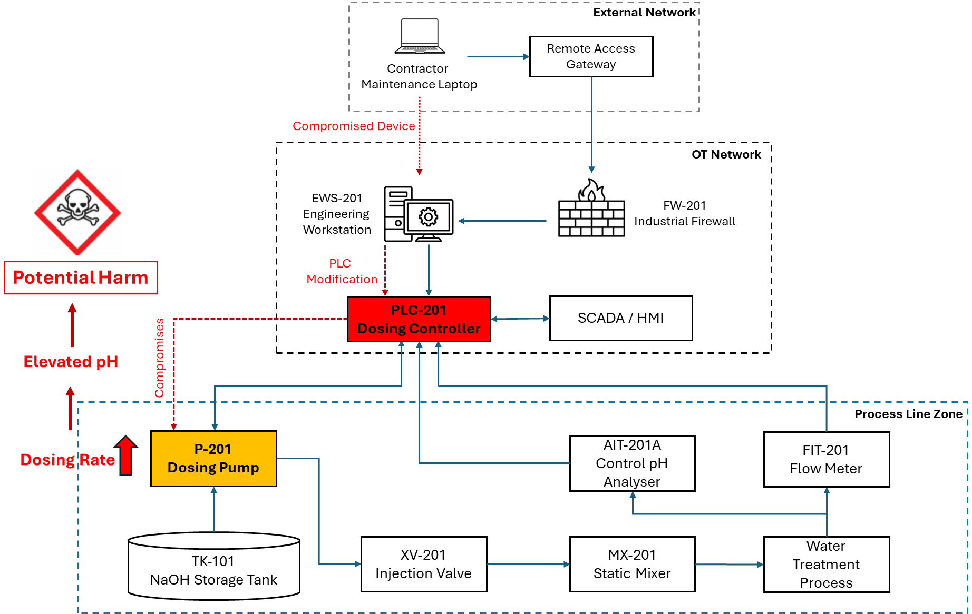

Answer the following questions.

What does the figure show?

Which component is most safety-critical?

Which component is most security-critical?

Where does the cyber-to-safety transition occur?

Incident Response Task
You are part of the response team.
Your task is to respond to the incident while protecting safety.
Assume the increase in sodium hydroxide dosing has been detected and the facility is operating in a degraded state. Your response actions should prioritise safety, process stability, and incident containment.

First Response Actions
List the first five actions you would take.
Priority | Action | Why This Action Matters
1
2
3
4
5

Stakeholder Coordination
Who needs to be involved in the response?

Stakeholder | What They Know | What They Should Do
Cyber Security / SOC Team
OT / Engineering / Technical Team
Operations / Water Treatment Plant Operators
Safety / Risk Team
Vendor / External Support

Safety-Critical Decision
What actions should be taken to prevent unsafe water from entering the distribution network while the incident is being investigated?
What information is needed before making that decision?

Mitigation Analysis
Analyse possible mitigations.
Classify each mitigation as one or more of the following:
- Preventive: reduces the likelihood of the incident.
- Detective: helps identify the incident or deviation.
- Protective: limits unsafe physical consequences.
- Recovery: supports safe restoration.

Mitigation | Preventive | Detective | Protective | Recovery | Explanation

Suggested mitigations to analyse
- Multi-factor authentication
- Time-limited maintenance access
- Approval-based remote sessions
- Continuous monitoring of remote connections
- Engineering workstation hardening
- Endpoint protection
- Network segmentation
- Independent pH sensor
- Safety PLC
- Automatic trip logic
- Pump shutdown
- Valve isolation

Security Controls vs Safety Controls
Security controls and safety controls do different things, but both may be needed.
Complete the table (add more rows, if necessary)
Control | Security Control or Safety Control? | What Risk Does It Reduce? | What Happens If It Fails?

Note: Some controls in this episode are cyber security controls and some are safety controls. Students should identify which category each control belongs to and explain how they complement one another.

Trade-Offs and Tensions
Cyber security and safety goals may sometimes create tension.
Identify one tension in the episode.
Examples may include:
- Remote access convenience versus secure access control.
- Operational efficiency versus restricted maintenance access.
- System connectivity versus network segmentation.
- Automation versus independent safety protection.
- Availability of remote support versus risk of trusted-path compromise.

What is the tension?

Why is it difficult to resolve?

How should it be managed?

Security-Informed Safety Reflection
Answer the following questions.

Why is this scenario not only a cyber security problem?

Why is this scenario not only a safety problem?

What does this episode teach about Security-Informed Safety?

Group Discussion Task
In small groups, discuss the following.
Task
You are advising the municipal water utility after the incident described in the episode.
Prepare three recommendations:
- One recommendation to reduce the likelihood of the cyber event.
- One recommendation to detect or identify the developing hazard.
- One recommendation to reduce harm if the hazard occurs.
Recommendation Type | Recommendation | Justification
Reduce likelihood
Detect hazard
Reduce harm

Short Written Response
Write a short answer, approximately 150–250 words.
Explain how the episode demonstrates the relationship between cyber security, safety, and operational decision-making.

Optional Extension Task
Choose one of the following.
Option A: Improve the Architecture
Suggest one change to the system architecture that would reduce cyber-to-physical risk.

Option B: Improve the Incident Response Plan
Suggest one change to the incident response process that would improve safety during recovery.

Option C: Improve Human Decision-Making
Suggest one way to support operators, engineers, clinicians, or other staff during degraded operation.

Option D: Improve the Safety Instrumented Function
Propose one additional independent safety measure that could further reduce the consequences of excessive sodium hydroxide dosing.

Checklist Before Submission
Before submitting, check that you have:
- identified the cyber event
- identified the hazard
- distinguished hazard from harm
- completed the hazard-threat map
- completed the cyber-to-physical pathway
- proposed incident response actions
- analysed mitigations
- considered both security and safety controls
- explained the Security-Informed Safety lesson

