Security-Informed Safety Educational Resource
Student Worksheet

Student Name:
Student ID:
Episode Title: Maritime GPS Spoofing and Navigation Integrity Failure (Novel Technologies and Resilience)
Associated Video: Episode 3 – Maritime GPS Spoofing and Navigation Integrity Failure

Purpose of this Worksheet
This worksheet helps you analyse how cyber security events can create, worsen, or reveal safety risks in cyber-physical systems.
You will examine:
- the system being protected
- the cyber security event
- the safety hazard
- the possible consequences
- appropriate incident response actions
- and suitable mitigation strategies.
The aim is not only to identify a cyberattack, but to understand how cyber events can influence physical processes, operational decisions, and safety outcomes.

Scenario Summary
Modern maritime navigation is heavily reliant on Positioning, Navigation, and Timing (PNT) information provided by Global Navigation Satellite Systems (GNSS). Maritime bridge systems for vessel position information include Electronic Chart Display and Information Systems (ECDIS), Automatic Identification Systems (AIS), route-monitoring functions, and track-control systems. These technologies increase the navigational accuracy and operational effectiveness of navigation, but also induce new dependencies on digital information.
Unlike most conventional safety risks, cyber incidents may be unrelated to damage to physical equipment. Instead, they can blur the validity of operational data and pose the danger of making unsafe decisions driven by inaccurate information.
GNSS spoofing is a major challenge in maritime environments. A successful spoofing attack can result in bridge systems that show a fake position for the vessel while appearing fully operable.
This episode deals with GNSS spoofing implications for navigational safety, how integrity loss caused by cyber-induced integrity failures can propagate through contemporary bridge systems, and robust navigation practices that can curtail danger.

System Context
What system is being examined?

Cyber Security Event
What cyber security event, compromise, disruption, or security-driven action occurs?

Safety Concern
What safety issue could result from the cyber event?

Main Security-Informed Safety Lesson
What is the main lesson from this episode?

Key Assets and Dependencies
Identify the important assets and dependencies in the scenario.

Asset / System Component | Role in Normal Operation | Why It Matters for Safety

Examples of asset/system components: Engineering Workstation, HMI, Pump, Sensor, Controller, etc.
The assets can be mentioned in high-level or very detailed, depending on the purpose of your study.

Suggested assets to consider
- Primary GNSS Receiver
- Secondary GNSS Receiver
- ECDIS
- AIS
- Radar / ARPA
- Gyrocompass
- Speed Log
- Echo Sounder
- Autopilot / Track Control System
- Integrated Bridge Network
- Bridge Team
- Passenger Ferry
- Harbour Navigation Corridor
- Visual Navigation References
- Navigational Aids (Buoys, Landmarks, Harbour Marks)

Hazard–Threat Map
Complete the table below.
A threat is a cyber security-related event or condition.
A hazard is an unsafe system state or condition.
Potential harm is the consequence that could affect people, equipment, services, or the environment.
Students should distinguish between:
- the cyber event
- the information integrity failure
- the unsafe control actions
- the resulting hazard
- the potential harm
Remember that GNSS spoofing itself is not the hazard.
The hazard emerges when compromised navigation information influences operational decisions and vessel movement.
The critical safety issue is not the spoofing attack itself but the physical consequences that arise when inaccurate navigation information is accepted as trustworthy

Threat / Cyber Event | Affected Asset or Function | Resulting Hazard | Potential Harm

Cyber-to-Physical Escalation Pathway
Complete the pathway showing how the cyber event can become a safety issue.
Cyber Event:
(GNSS Spoofing)
Write your answer here

Affected Digital / Control Function:
(False Position Data)
Write your answer here

Operational Deviation or Loss of Assurance:
(Incorrect ECDIS Position and Navigation Guidance)
Write your answer here

Hazard:
(Vessel Drifts Toward Navigational Hazard)
Write your answer here

Potential Harm:
(Grounding, Collision, Passenger Injury, Environmental Pollution)
Write your answer here

Now write the pathway as one short paragraph.
Write your answer here

Figure-Based Analysis

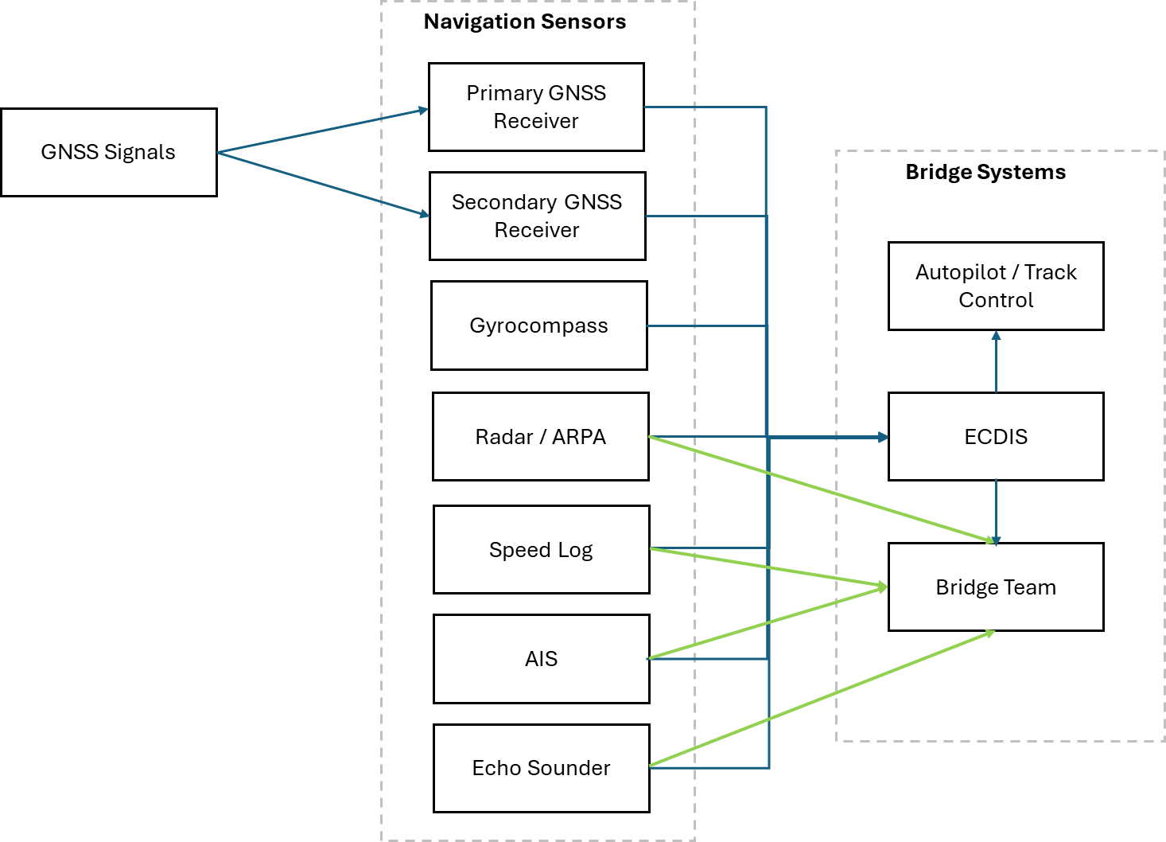

Answer the following questions.

What does the figure show?

Which component is most safety-critical?

Which component is most security-critical?

Where does the cyber-to-safety transition occur?

Incident Response Task
You are part of the response team.
Your task is to respond to the incident while protecting safety.
Assume the bridge team has identified inconsistencies between GNSS-derived position information and independent navigation sources. The vessel remains operational, but navigation confidence has been reduced. Your response actions should prioritise passenger safety, navigational safety, situational awareness, and hazard avoidance.

First Response Actions
List the first five actions you would take.
Priority | Action | Why This Action Matters
1
2
3
4
5

Stakeholder Coordination
Who needs to be involved in the response?

Stakeholder | What They Know | What They Should Do
Cyber Security / SOC Team
OT / Engineering / Technical Team
Bridge Team
Vessel Master / Captain
Navigation Officers
Maritime Operations Centre
Cyber Security Support Team
Vessel Technical Support Team
Harbour Traffic Services (if applicable)
Vendor / External Support

Safety-Critical Decision
What actions should be taken to maintain safe navigation while the integrity of the vessel's position information is being investigated?
What information is needed before making that decision?
Should automated track-control functions continue to be used, or should navigation transition to increased manual oversight and independent verification?

Mitigation Analysis
Analyse possible mitigations.
Classify each mitigation as one or more of the following:
- Preventive: reduces the likelihood of the incident.
- Detective: helps identify the incident or deviation.
- Protective: limits unsafe physical consequences.
- Recovery: supports safe restoration.

Mitigation | Preventive | Detective | Protective | Recovery | Explanation

Suggested mitigations to analyse
- Cross-sensor verification
- Radar observations
- Visual bearings
- Echo sounder verification
- Heading and speed cross-checks
- GNSS integrity monitoring
- Diverse navigation sources
- Independent position verification
- Bridge-team anomaly training
- Reduced-speed procedures
- Manual navigation procedures
- Human oversight
- Defence-in-depth navigation architecture
- Mixed-trust sensor design

Security Controls vs Safety Controls
Security controls and safety controls do different things, but both may be needed.
Students should distinguish between controls intended to protect navigation information and controls intended to maintain safe vessel operation. Some measures support both objectives, but navigation safety ultimately depends on recognising when trusted information may no longer be trustworthy.
Complete the table (add more rows, if necessary)
Control | Security Control or Safety Control? | What Risk Does It Reduce? | What Happens If It Fails?

Note: Some controls in this episode are cyber security controls, and some are safety controls. Students should identify which category each control belongs to and explain how they complement one another.

Trade-Offs and Tensions
Cyber security and safety goals may sometimes create tension.
Identify one tension in the episode.
Examples may include:
- Automation versus human oversight.
- GNSS convenience versus independent verification.
- Efficiency versus navigational resilience.
- Single-source navigation versus sensor diversity.
- Operational confidence versus information uncertainty.
- Trust in automation versus manual intervention.

What is the tension?

Why is it difficult to resolve?

How should it be managed?

Security-Informed Safety Reflection
Answer the following questions.

Why is this scenario not only a cyber security problem?

Why is this scenario not only a safety problem?

What does this episode teach about Security-Informed Safety?

Group Discussion Task
In small groups, discuss the following.
Task
You are advising the ferry operator after the GNSS spoofing incident described in the episode.
Prepare three recommendations:
- One recommendation to reduce the likelihood of the cyber event.
- One recommendation to detect or identify the developing hazard.
- One recommendation to reduce harm if the hazard occurs.
Recommendation Type | Recommendation | Justification
Reduce likelihood
Detect hazard
Reduce harm

Short Written Response
Write a short answer, approximately 150–250 words.
Explain how the episode demonstrates the relationship between cyber security, safety, and operational decision-making.

Optional Extension Task
Choose one of the following.
Option A: Improve the Architecture
Suggest one change to the system architecture that would reduce cyber-to-physical risk.

Option B: Improve the Incident Response Plan
Suggest one change to the incident response process that would improve safety during recovery.

Option C: Improve Human Decision-Making
Suggest one way to support operators, engineers, clinicians, or other staff during degraded operation.

Option D: Improve Navigation Resilience
Propose one additional method for detecting navigation-information integrity failures before they influence vessel movement.

Checklist Before Submission
Before submitting, check that you have:
- identified the cyber event
- identified the hazard
- distinguished hazard from harm
- completed the hazard-threat map
- completed the cyber-to-physical pathway
- proposed incident response actions
- analysed mitigations
- considered both security and safety controls
- explained the Security-Informed Safety lesson

